AZURE TERRAFORM

**Aim**: - Install and configure terraform and Visual studio code.

# **To Install and configure terraform and Visual studio code.**

**Install and configure terraform:**

To download terraform by using the following link:

- <https://developer.hashicorp.com/terraform/downloads>

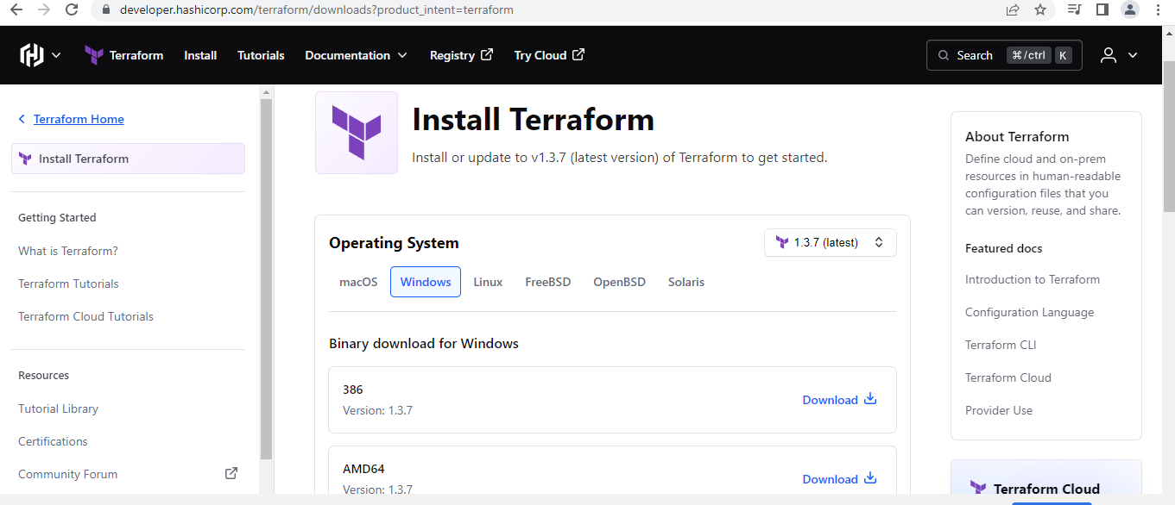

To create a folder terraform in c:>program files:

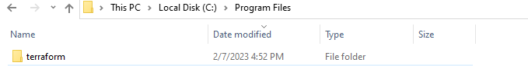

Terraform.exe file extract to terraform folder:

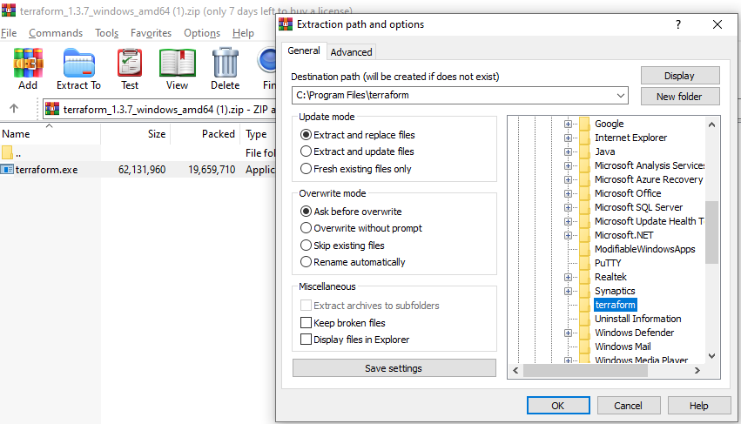

To check the executable file in c :> program files>terraform:

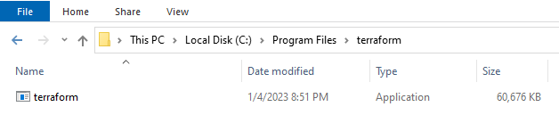

To add the environment variable: Path- C:\Program Files\terraform

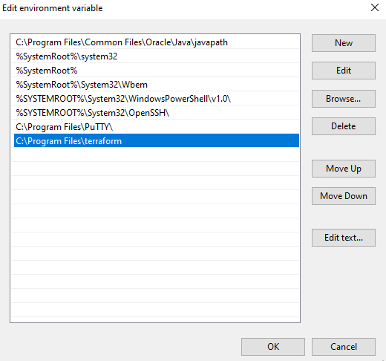

To open command prompt and check the terraform version by using the following the command:

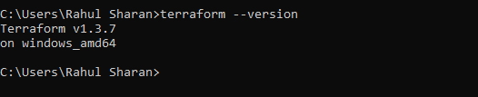

**Install and configure Visual studio code:**

To download Visual studio code by using the following link:

-https://code.visualstudio.com/download

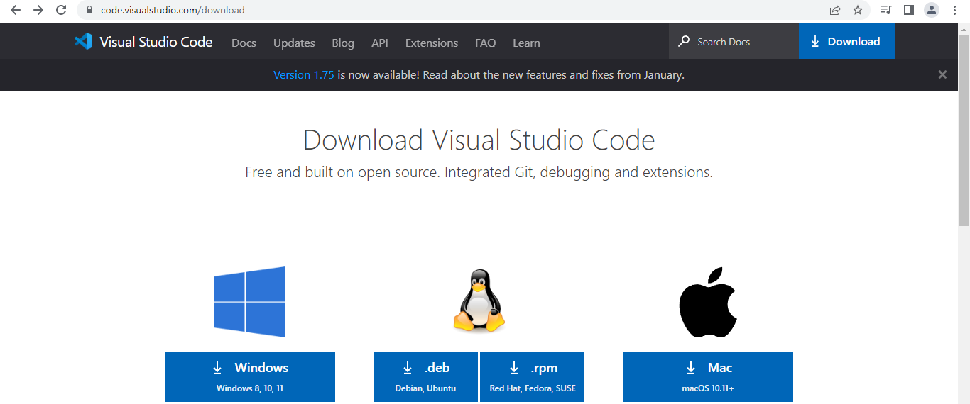

To install Visual studio code:

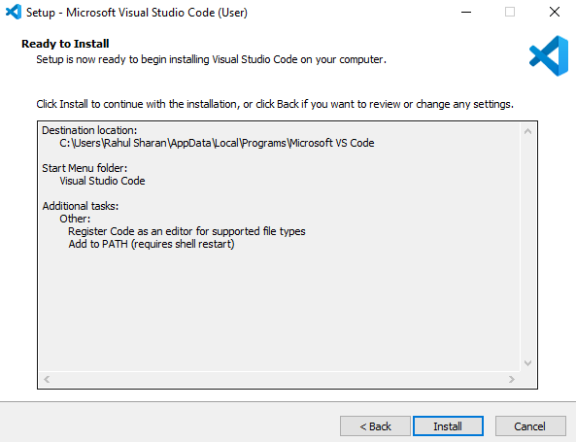

To add extensions in VScode -terraform and azure terraform:

